SonarQube Code Review
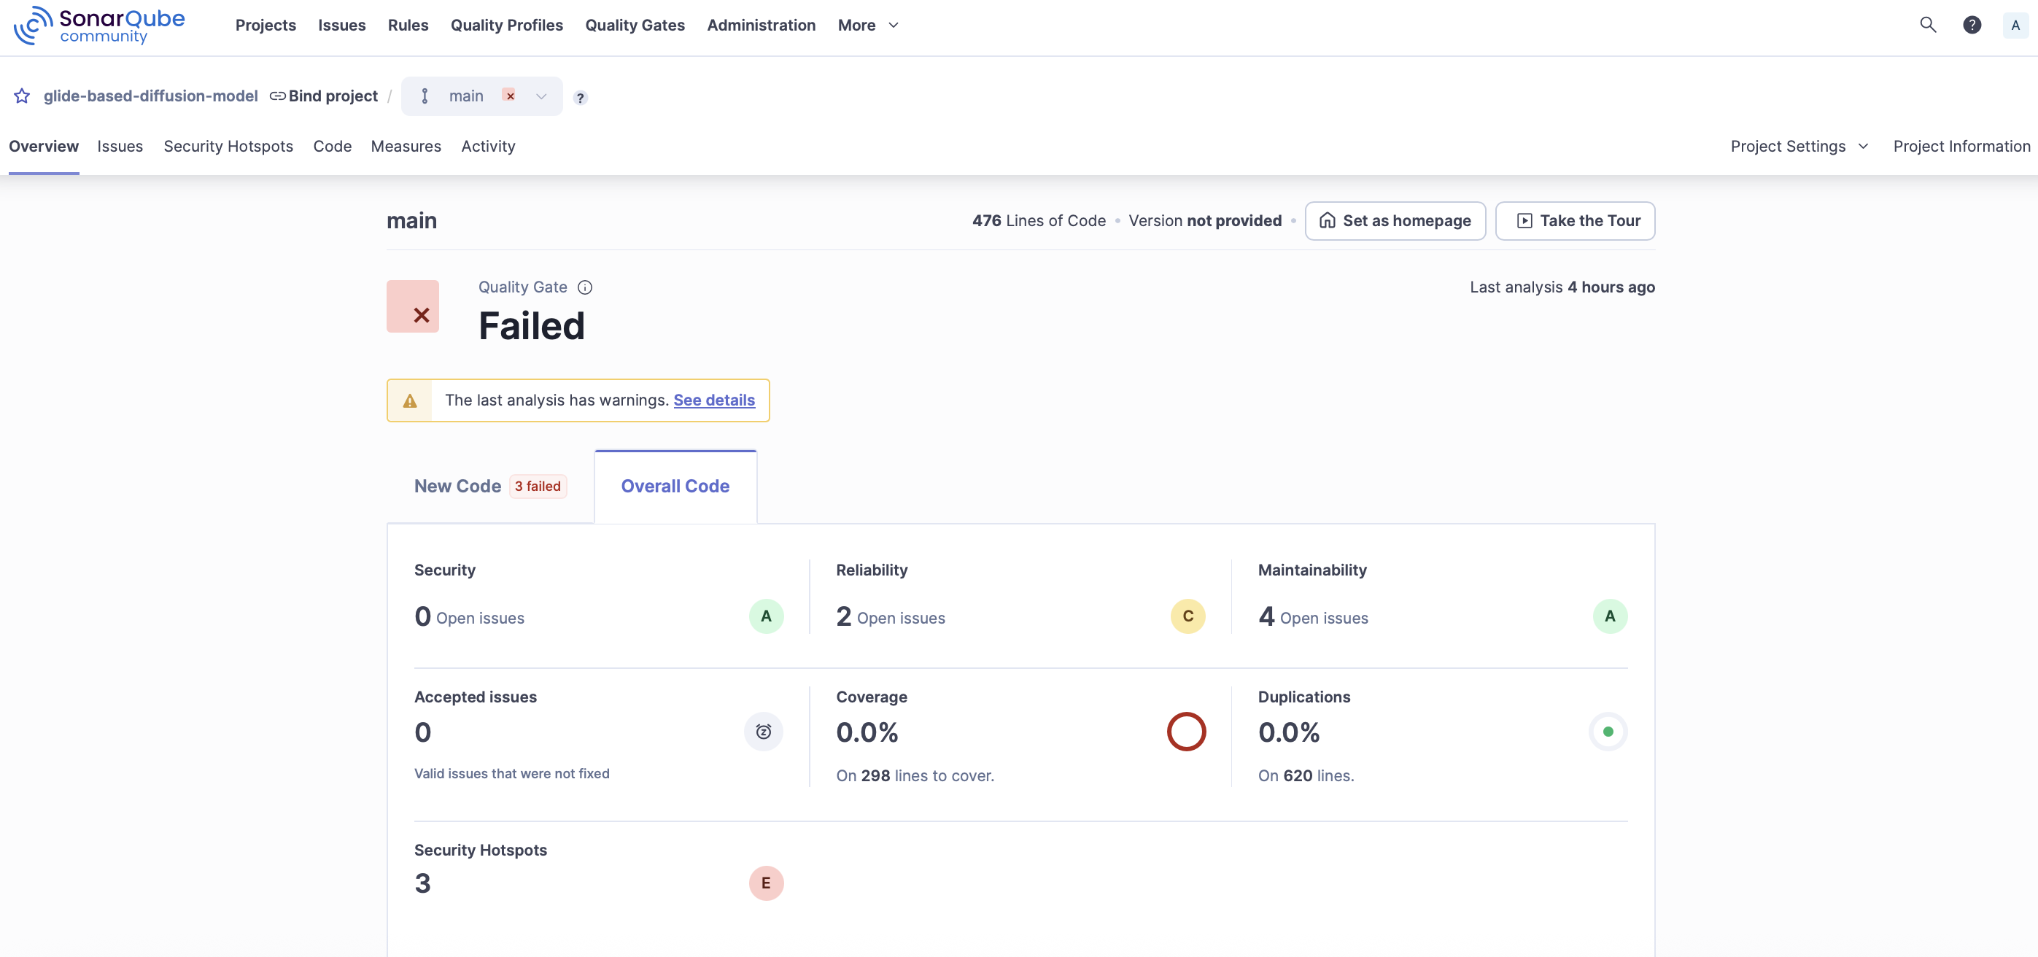
For the Glide-based Diffusion model, 423 tests were successful and 10 tests failed.
The code build is mostly functional for our use case. An initial error of “model” module not found was fixed.

